**Preliminary Analysis:** With the currently available data, we have done a small case of study to test the pipeline for Aim1.All the source code of these preliminary analysis are available in Vera-Licona’s repository https://github.com/VeraLiconaResearchGroup/Chemotherapy-Resistance-Reversion.

**Preliminary *Resistance Network****:*We have built a preliminary resistance signaling network that consists of 681 nodes, and 2634 edges. This network was built taking the union of the subnetworks for each pairwise comparison with all RNA-seq datasets and the only one available ATAC-seq dataset at T1 (Aim1a is to generate ATAC-seq at T2). The functionally enriched gene layer contains 586 genes. TRANSFAC and IPA identified 38 TFs. For the final network layer, 7 master regulators were identified. The network has 13 genes known to be associated with TNBC, including BACH2, FOXM1, SMAD4, TWIST1, and SOX9 [43–46]. There are 29 genes known to be associated with cisplatin resistance, including BCL2, LEF1, STAT3, E2F1, WEE1 and two genes, SMAD3, BLM, associated with cisplatin sensitivity [47–53]. Heatmaps with hierarchical clustering showed the network nodes separate between treated and untreated samples using normalized expression values from RNA-seq data. The network nodes showed to be differentially expressed among subclonal population according to preliminary expression analysis from isolated subclones from the bulk TM00099 tumor thus indicating that the preliminary network can capture the differences in subclonal populations, including that with acquired resistance (Fig. 3). There were 32 readout nodes in the T2 Resistant *vs.* Vehicle and 32 in the T2 Sensitive *vs*. Vehicle comparison. 24 of these nodes were in common between the two samples.

**Attractor Analysis with SFA.** We estimated the attractors from the Vehicle, Resistant, and Sensitive initial states. The direction of activity change of readout nodes was calculated between the T2 Resistant *vs.* Vehicle and T2 Sensitivity *vs.* Vehicle attractors. For each readout node and each comparison, the direction of activity change was compared to the corresponding readout’s log2 FC values from our RNA-seq data. For both, T2 Resistant *vs.* Vehicle and T2 Sensitivity *vs.* Vehicle comparisons, the readout’s direction of activity changes matched our RNA-seq data, giving evidence that SFA is yielding reliable results.

**FC Control Analysis.** There were 20 FVS, each containing 24 nodes. Because the network has 11 source nodes, each of the 20 FC control sets contains 1 FVS of 24 nodes and 11 source nodes, for a total of 35 nodes. One FC control set, *FC1*, was chosen for further analysis. FC1 contains known TNBC and cisplatin sensitivity-associated gene SMAD3[52,54] and known cisplatin resistance markers EGFR, JUN, MAPK1[55–57].

***In Silico* Screening on FC1 Set.** SFA was performed taking as input our resistance network, the RNA-seq normalized expression values of the T2 Resistant sample and a set of perturbations (activations or inhibitions) on FC1. SFA ran until reaching an attractor. A perturbation pattern is deemed successful if, we observe a change in the direction of expression of as many resistance readout nodes from those expression values in the T2 Resistance attractor. After 100,000 simulations, one perturbation pattern was found to successfully change 8 of the readout nodes’ attractor activity. For these 8 genes KRT18, MYB are known cisplatin resistance associated genes[58,59]. Additionally, ARRB1 is a known cisplatin sensitive gene[60]. The direction of activity change agrees with the literature on the gene’s role is cisplatin resistance/sensitivity for ARRB1 and MYB. KIT has been cited as a candidate for oncogene addiction in gastrointestinal stromal tumors, and MYB an oncogene addiction target in leukemia[61,62] neither are known oncogene addiction genes in TNBC.

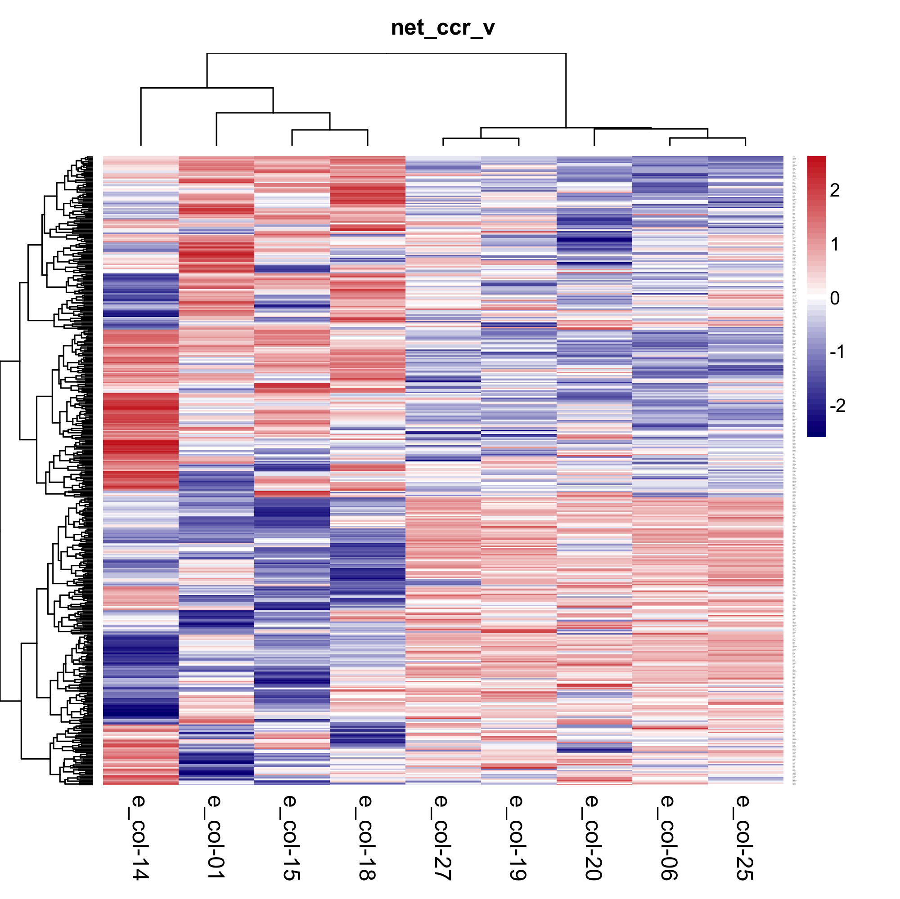

Figure 3. Heatmap of Preliminary Network Genes on Tumor Subclonal Populations. Network genes are differentially expressed among subclonal population according to preliminary analysis of expression from isolated subclones from the bulk TM00099 tumor, indicating that the network constructed could represent differences in subclonal populations.